21STICKS – Carlos Leandro Asano

PROBLEM TESTING

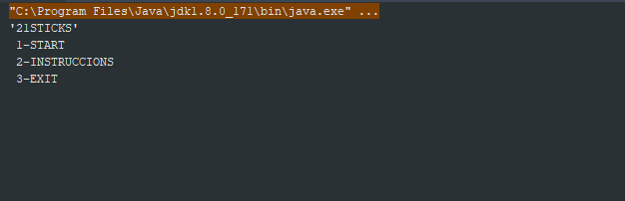

CASE 1:

* Key enter: “a”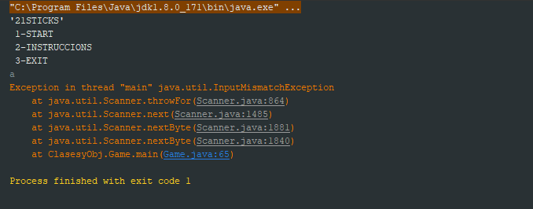

Error of type detected.

CASE 2:

* Key enter: “1”-“2”-“Leandro”-“Sandino”

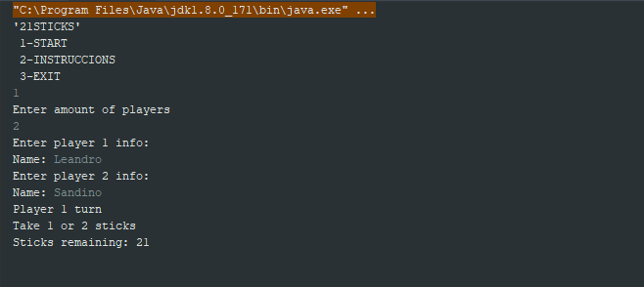

* Key enter: “1”-“2”-“2”-“4”-“0”

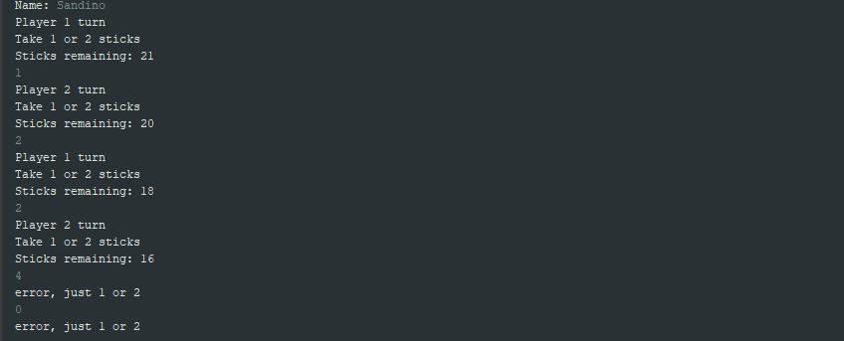

* Key enter: “2”-“2”-“2”-“2”-“2”-“2”

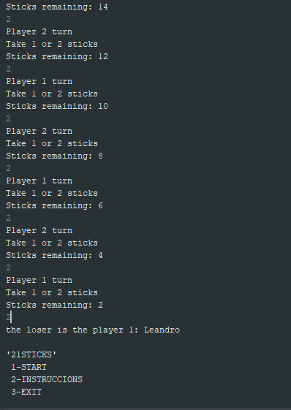

CASE 3:

* Key enter: “1”-“3”-“Leandro25”-“038.5”-“Sandino,.”

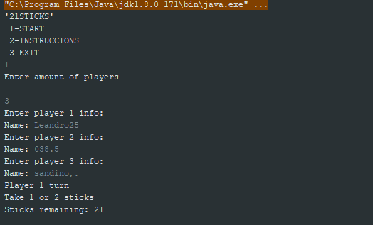

* Key enter: “2”-“2”-“1”-“1”-“1”-“1”-“1”

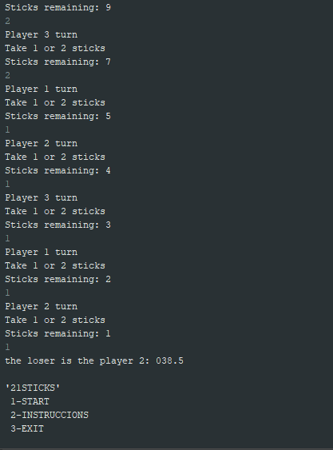

CASE 4:

* Key enter: “1”-“g”

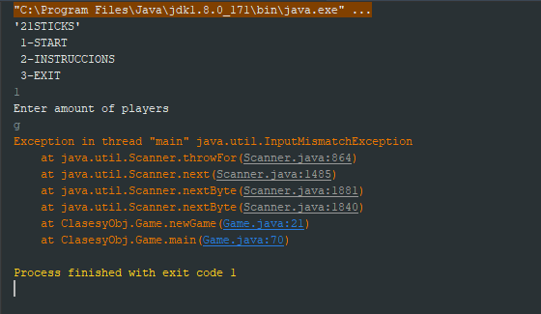

CASE 5:

* Key enter: “2”-“3”

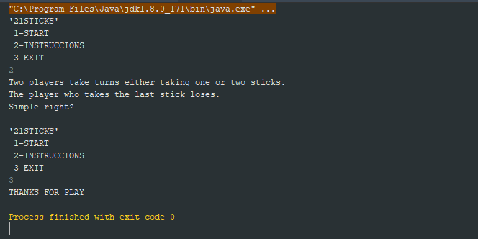

CASE 6:

* Key enter: “1”-“0”-“-2”-“1”-“4”-“Hola”-“leo”-“ale”-“santi”

